# **Final Sprint 1**

Total Story Points: 15 Total Hours Estimate: 78

Estimated Velocity: 15  
Actual Velocity: ~7 Total Hours Taken:

## **Welcome Page - Story ID: 14**

|  |  |  |  |
| --- | --- | --- | --- |
| Task ID | Task Description | Estimate | Taken |
| 1 | HTML page interface display | 5 | 4 |
| 2 | Navigation bar adaptive functionality | 1 | 0.5 |
| 3 | Verify story is complete (unit tests) | 3 | 5 |
|  | Story Points: 1 Total Hours: | 8 | 9.5 |

## **User Login - Story ID: 2 - Story is combination of old Login stories**

|  |  |  |  |
| --- | --- | --- | --- |
| Task ID | Task Description | Estimate | Taken |
| 1 | HTML page interface display | 3 | 5 |
| 2 | Account validation function | 5 | 2 |
| 3 | Pass data to back end | 3 | 1 |
| 4 | Account Session handling | 5 | 3 |
| 5 | Verify story is complete (unit tests) | 5 | 6 |
|  | Story Points: 4 Total Hours: | 21 | 17 |

## **Student Account Management - Story ID: 10**

|  |  |  |  |
| --- | --- | --- | --- |
| Task ID | Task Description | Estimate | Taken |
| 1 | HTML page interface display | 3 | 4 |
| 2 | Verify story is complete (unit tests) | 3 | 6 |
|  | Story Points: 1 Total Hours: | 6 | 10 |

## **Staff Management Page - Story ID: 13**

|  |  |  |  |
| --- | --- | --- | --- |
| Task ID | Task Description | Estimate | Taken |
| 1 | HTML page interface display | 4 | 4 |
| 2 | Verify story is complete (unit tests) | 3 | 6 |
|  | Story Points: 1 Total Hours: | 7 | 10 |

## **Potential Employee Contact - Story ID: 24**

|  |  |  |  |
| --- | --- | --- | --- |
| Task ID | Task Description | Estimate | Taken |
| 1 | HTML page interface display | 3 | 3 |
| 2 | File upload | 5 | 4 |
| 3 | Save file to database | 5 | 7 |
| 4 | Verify story is complete (unit tests) | 5 | NF (6) |
|  | Story Points: 4 Total Hours: | 18 |  |

## **Student Account Creation - Story ID: 1 - Added to sprint 1 - Not finished**

|  |  |  |  |
| --- | --- | --- | --- |
| Task ID | Task Description | Estimate | Taken |
| 1 | HTML page interface display | 3 | 4 |
| 2 | Save form submission data to database | 5 | 7 |
| 3 | Create student login in Django | 2 | 2 |
| 4 | Verify story is complete (unit tests) | 5 | NF(6) |
|  | Story Points: 4 Total Hours: | 18 |  |

# **Redefined stories in sprint 1**

## **Student Login - Story ID: 2 Merged with Staff Login into “User Login” Story**

|  |  |  |  |
| --- | --- | --- | --- |
| Task ID | Task Description | Estimate | Taken |
| 1 | HTML page interface display | 3 | - |
| 2 | Account validation function | 5 | - |
| 3 | Account Session handling | 5 | - |
| 4 | Verify story is complete (unit tests) | 5 | - |
|  | Story Points: 2 Total Hours: |  |  |

## **Staff Login - Story ID: 12 Merged with Student Login into “User Login” Story**

|  |  |  |  |
| --- | --- | --- | --- |
| Task ID | Task Description | Estimate | Taken |
| 1 | HTML page interface display | 3 | - |
| 2 | Account validation function | 5 | - |
| 3 | Account Session handling | 5 | - |
| 4 | Verify story is complete (unit tests) | 5 | - |
|  | Story Points: 2 Total Hours: | 18 | - |

# **Removed stories in sprint 1**

## **Editing the Databases - Story ID: 28 - Removed from sprint 1 to be refined**

|  |  |  |  |
| --- | --- | --- | --- |
| Task ID | Task Description | Estimate | Taken |
| 1 | HTML page interface display | 3 | - |
| 2 | Edit database function | 6 | - |
| 3 | Delete database function | 6 | - |
| 4 | Search filter | 10 | - |
| 5 | Verify story is complete (unit tests) | 6 | - |
|  | Story Points: 8 Total Hours: | 31 | - |

**Final Sprint 1 Changes Explained**

18/04/2018 - Editing the databases - **Chris Haywood(developer)** meeting with Isaiah Dunrobin(Product owner) and team

I engaged the team during the scheduled team meeting about the possibility of removing the “Editing the databases” story from the first sprint and redefining the story in the second sprint, the team agreed. The reasoning for this decision was because as the team worked on the project we found out that it would be impractical from a development perspective to create a webpage and functions for editing the databases (student and staff databases) when these databases did not yet exist in a coherent form.

It was decided that the student database would first need to be created for and populated with data from the “Student account creation” story (ID:1 ) functionality, before “Editing the databases” story(ID:28) could be fully created and tested. To achieve this the group decided to use django’s own admin features which are accessed from the admin page, on this page you can edit and delete entries from a database.   
  
Whilst using Django’s systems may help the project to be completed faster with robust features for handling the implementation of the databases, the full extent of how these systems can be used by the project is not fully understood. As such, the group has not yet decided on what the changes to the “Editing the databases” story(ID:28) will be as we are still unsure on how much of that story can be provided by the Django framework. This story will be a major point of discussion for the next sprint, as much of the requirements for it are already being delivered by other stories and the Django admin page.

## **Student Account Creation - Story ID: 1 - Added to sprint 1**

|  |  |  |  |
| --- | --- | --- | --- |
| Task ID | Task Description | Estimate | Taken |
| 1 | HTML page interface display | 3 | - |
| 2 | Save form submission data to database | 5 | - |
| 3 | Create student login account in Django | 2 | - |
| 4 | Verify story is complete (unit tests) | 5 | - |
|  | Story Points: 4 Total Hours: | 18 | - |

## **Editing the Databases - Story ID: 28 - Removed from sprint 1 to be refined**

|  |  |  |  |
| --- | --- | --- | --- |
| Task ID | Task Description | Estimate | Taken |
| 1 | HTML page interface display | 3 | - |
| 2 | Edit database function | 6 | - |
| 3 | Delete database function | 6 | - |
| 4 | Search filter | 10 | - |
| 5 | Verify story is complete (unit tests) | 6 | - |
|  | Story Points: 8 Total Hours: | 31 | - |

12/04/2018 - Meeting with team about login design - **Isaiah Dunrobin(Product owner)** and Leo Yoon(Developer)

15th of April during a group meeting Leo and I pointed out that the staff login and student login stories were able to redefine and merge into a single story. This was because during the sprint the team discovered that most of the login functionality such as session authentication can be handled by the Django framework and it’s own “Authentication Database” and “Login System”.

The issue was further discussed among team member who came to agree that they could be merged. With django it will be easiest to sort out the staff and students under Django’s prebuilt login system and database. This change had a positive effects on the project by reducing redundancy and insuring efficiency by not needing to repeat the same functions with the two login pages.

The new “User Login” story (ID:2) was created and refined to reflect this decision and will help to provide a better product for the client.

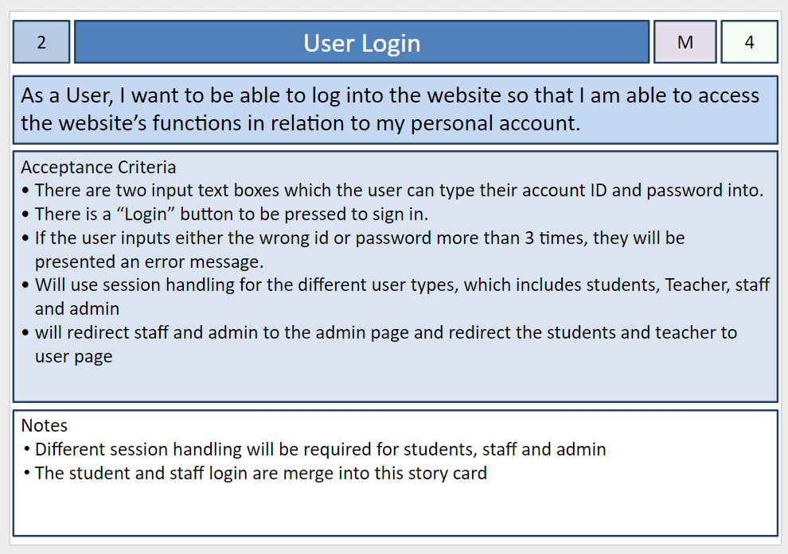

## **Staff Login - Story ID: 12 Merged with Student Login into a single ‘User Login’ Story**

|  |  |  |  |
| --- | --- | --- | --- |
| Task ID | Task Description | Estimate | Taken |
| 1 | HTML page interface display | 3 | - |
| 2 | Account validation function | 5 | - |
| 3 | Account Session handling | 5 | - |
| 4 | Verify story is complete (unit tests) | 5 | - |
|  | Story Points: 2 Total Hours: | 18 | - |

## **User Login - Story ID: 2**

|  |  |  |  |
| --- | --- | --- | --- |
| Task ID | Task Description | Estimate | Taken |
| 1 | HTML page interface display | 3 |  |
| 2 | Account validation function | 5 |  |
| 3 | Pass data to back end | 3 |  |
| 4 | Account Session handling | 5 |  |
| 5 | Verify story is complete (unit tests) | 5 |  |
|  | Story Points: 4 Total Hours: | 21 |  |